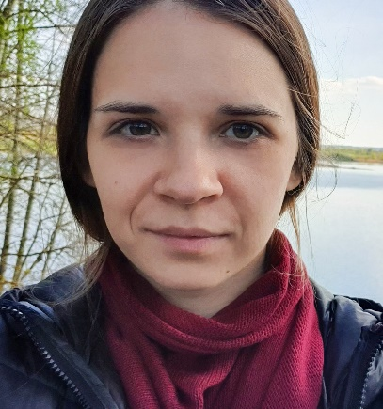**Inna Dragun**

**Junior Frontend developer (React)**

Minsk, Belarus

+375 (29) 316 01 28 | [innadragun.id@gmail.com](mailto:innadragun.id@gmail.com)

LinkedIn: <https://www.linkedin.com/in/inna-dragun-57b30b151/>

SUMMARU

* Experience in creation a landing pages and multi-pages websites, creating new features, supporting existed sites (HTML, CSS, JQuery), over 2 years
* Experience in React 0,5 year
* Experience in teamwork

SKILLS

* Programming: JavaScript (ES6)
* UI: HTML, CSS (SASS, LESS), Bootstrap, Material UI
* Libraries: JQuery, React, React-Router
* Package manager: NPM
* Build project tool: Gulp
* Tools: VSCode, Photoshop, Figma, Zeplin
* English: writing Intermediate, speaking Pre-Intermediate
* Other: Github, REST API

Desire to get knowledge and experience in TypeScript, Redux

EXPERIENCE

**Frontend developer (React)** Freelance

Jun 2020 – Nov 2020

* <https://excelano.com/>
* Description: development of a Single page website
* Technologies: HTML, CSS (SASS), JQuery, Gulp
* A project management application (Startup)
* Description: The main functions are to organize, plan and collaborate. The application allows leading projects, including its funding.

Experience in communication with a foreign customer, work in a team.

* Technologies: React, React-Router, Material UI, Webpack

**HTML-coder** at United Team

Feb 2018 – Now

* <https://rusautolack.ru/>
* Description: development of the official website of the company that deals with wholesale of aerosol paints
* Technologies: HTML, CSS (SASS), JQuery, Gulp
* <https://contragent.by/>
* Description: Development of a website - resource for searching information about contractors
* Technologies: HTML, CSS (LESS), JQuery, Gulp
* <https://udata.by/>
* Description: Completion of new features and bug fixes. Landing page for a product that deals with the management accounting
* Technologies: HTML, CSS
* <https://na.sonax.pro/>
* Description: Development of a website for the competition on best tuned car
* Technologies: HTML, CSS (LESS), JQuery

**Student** of the HTP “IT Academy”

Dec 2019 – Feb 2020

* Weather application. <https://github.com/Inna-ID/WeatherApp_JS>
* Description: The application allows to find out the currently and five days hourly weather and weather conditions for any city in the world. An “Open weather” API was used.
* Technologies: HTML, CSS (SASS), JavaScript, open API

EDUCATION

**Frontend development course of the HTP “IT Academy”**

Dec 2019 – Feb 2020

**Belarusian National Technical University**

Information Technologies and Robotic Faculty. Engineer

2014 - 2019

ADDITION

Job wishes: full-time, remote job